# **ESTADÍSTIQUES CUAPM**

| Registro+triage | 6min |
| --- | --- |
| Evaluacion medica | 8min |
| Pruebas | 10min |

| 0:0 | 9 |
| --- | --- |
| 1:00 | 6 |
| 2:00 | 6 |
| 3:00 | 6 |
| 4:00 | 6 |
| 5:00 | 3 |
| 6:00 | 3 |
| 7:00 | 6 |
| 8:00 | 12 |
| 9:00 | 12 |
| 10:00 | 15 |
| 11:00 | 15 |
| 12:00 | 15 |
| 13:00 | 18 |
| 14:00 | 15 |
| 15:00 | 18 |
| 16:00 | 18 |
| 17:00 | 15 |
| 18:00 | 18 |
| 19:00 | 18 |
| 20:00 | 18 |
| 21:00 | 18 |
| 22:00 | 15 |
| 23:00 | 12 |

| 5 de cada 100 despues de registro triage->ambulancia  patologia:  50%medicina general  30% trauma  20%pedia  pruebas:  70%trauma  10%pedia  5%medicina  silla ruedas:  60% de los de trauma  5% de medicina general  5% pedia silla de ruedas |
| --- |

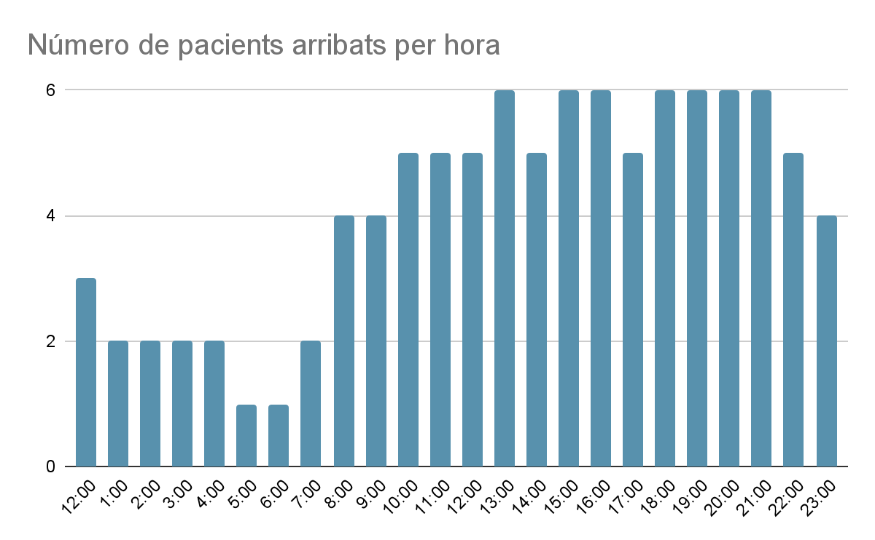

00:00:00 01:00:00 9

01:00:00 02:00:00 6

02:00:00 03:00:00 6

03:00:00 04:00:00 6

04:00:00 05:00:00 6

05:00:00 06:00:00 3

06:00:00 07:00:00 3

07:00:00 08:00:00 6

08:00:00 09:00:00 12

09:00:00 10:00:00 12

10:00:00 11:00:00 15

11:00:00 12:00:00 15

12:00:00 13:00:00 15

13:00:00 14:00:00 18

14:00:00 15:00:00 15

15:00:00 16:00:00 18

16:00:00 17:00:00 18

17:00:00 18:00:00 15

18:00:00 19:00:00 18

19:00:00 20:00:00 18

20:00:00 21:00:00 18

21:00:00 22:00:00 18

22:00:00 23:00:00 15

23:00:00 01:00:00:00 8